Learning Guide

Managing a Job Plan

25 October 2021





Table of Contents

Table of Contents 1
Introduction and Learning Objectives 2
Create a Route 3
Steps 3
Modify a Route 6
Steps 6
Delete a Route 8
Steps 8

Introduction and Learning Objectives

A Job Plan is a detailed description of work that is performed for a Work Order. Job Plans are applied to Preventive Maintenance (PM) records and Work Orders to create work plans. A Job Plan is added to a Work Order or PM record after the status of the Job Plan is changed to Active in Maximo.
A Job Plan is created prior to the creation of a Work Order or a PM record. After you apply a Job Plan to a Work Order, you can customize the work plan or the Work Order without affecting the original Job Plan.

By the end of this Learning Guide, you will be able to:
- Create a Job Plan
- Add Tasks to a Job Plan
- Add Planned Labor to a Job Plan
- Add Materials to a Job Plan
- Add Services to a Job Plan
- Duplicate a Job Plan

Job Plans are created using the Job Plans (Oil) application in Maximo. The mandatory fields for creating a Job Plan are:
- Job Plan Name
- Template Type
- Duration
- WO Priority

Create a Job Plan
Follow the steps below to create a Job Plan in Maximo.

Steps
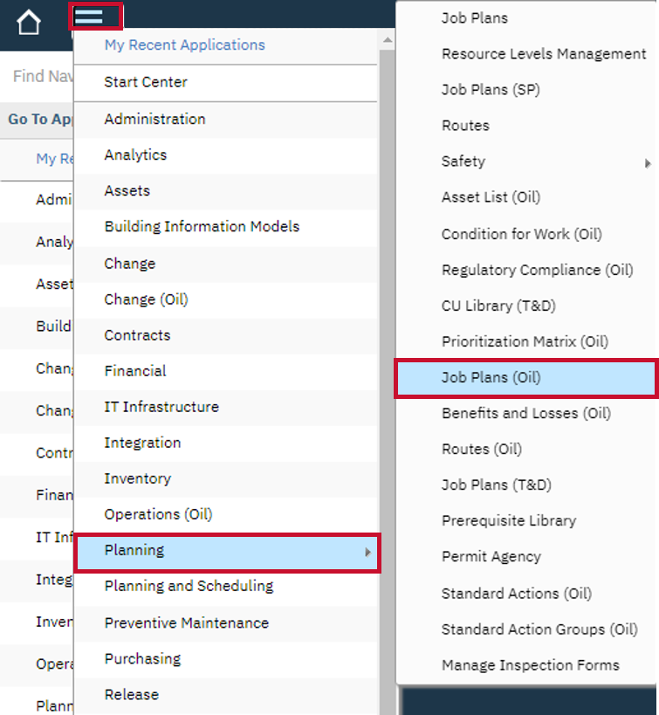
- After logging into Maximo, click the Go To icon, select the Planning option and then, select the Job Plans (Oil) application.

- In the Job Plans (Oil) application page, click the New Job Plan icon.
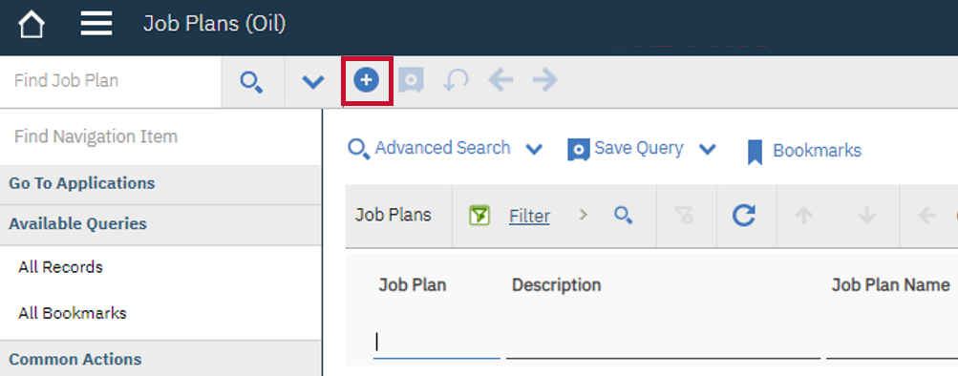

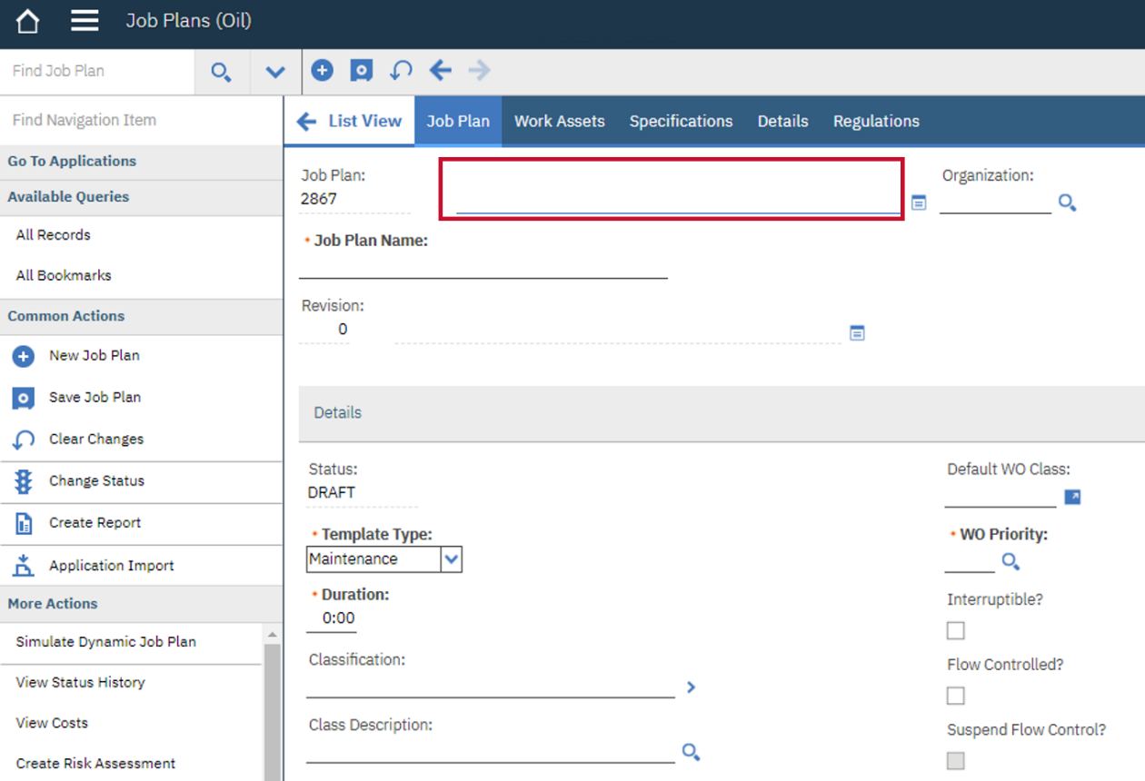
- Enter the description of the Job Plan in the Description field.

Note: The default Status of a new Job Plan is DRAFT.
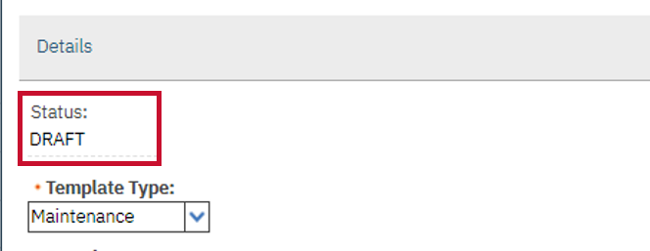

- Enter a name for the Job Plan in the Job Plan Name field.
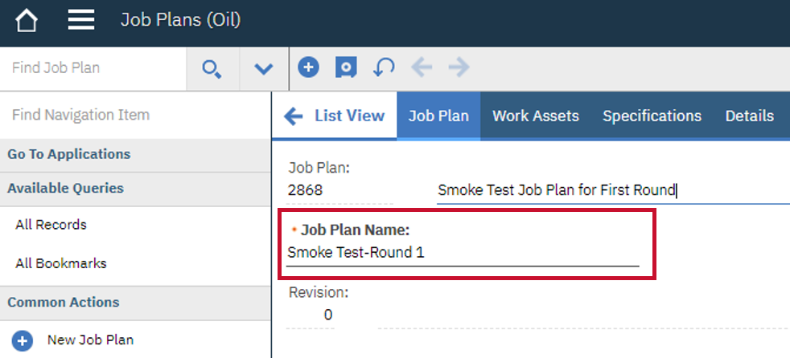

Note: You can click the Paper Clip icon in the Attachments field to add documents, if required.
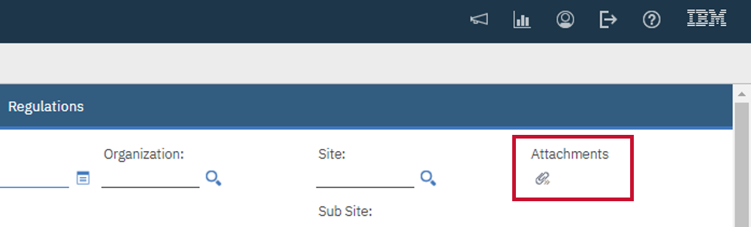
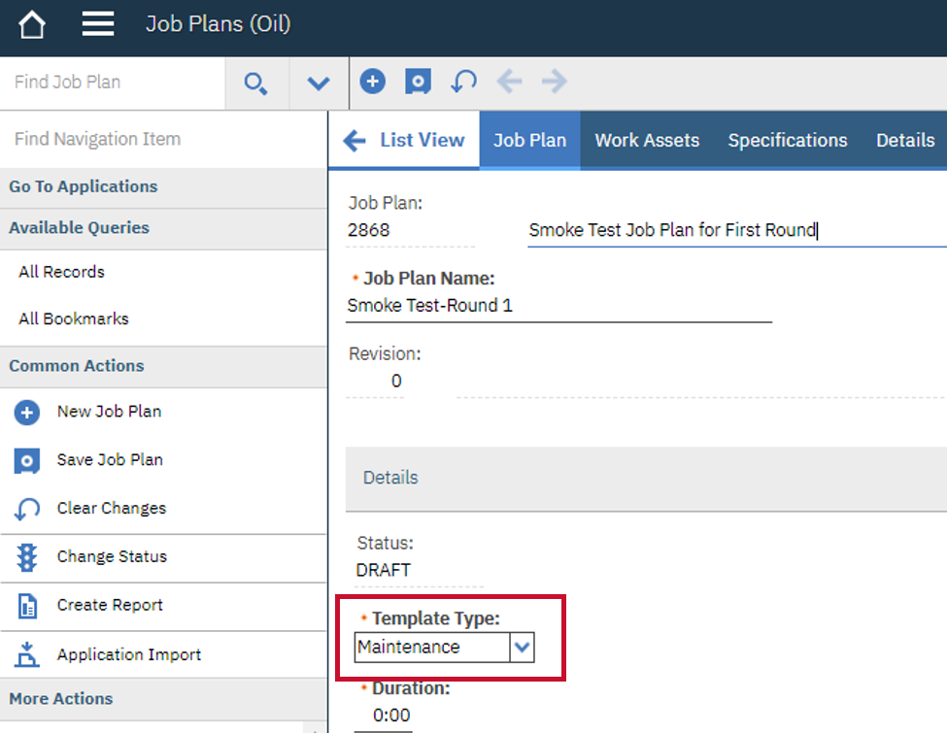
- Select a Template Type from the drop-down list. In this example, Maintenance is selected.

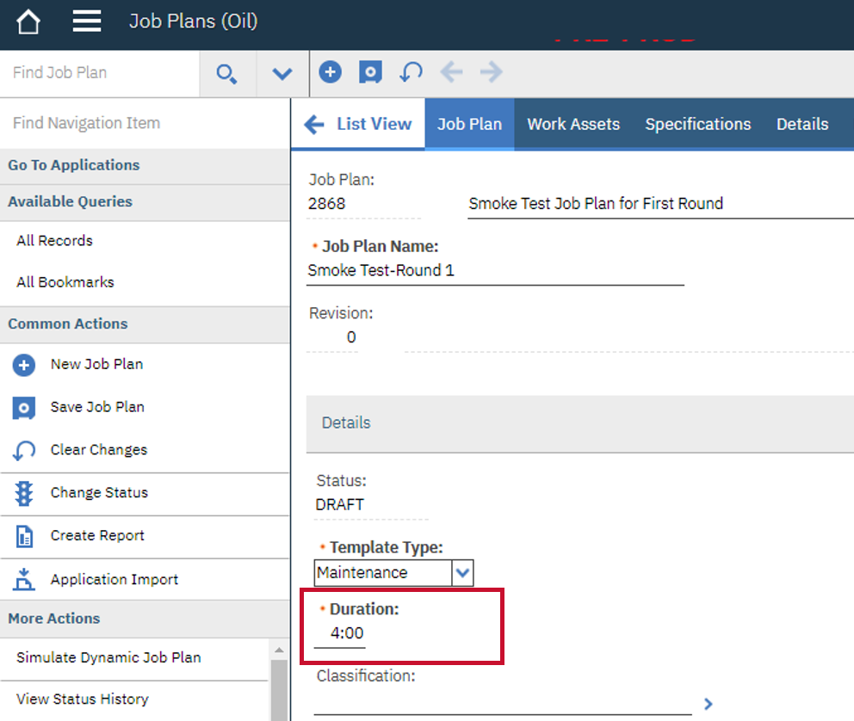
- Enter the time required to complete the job in the Duration field.

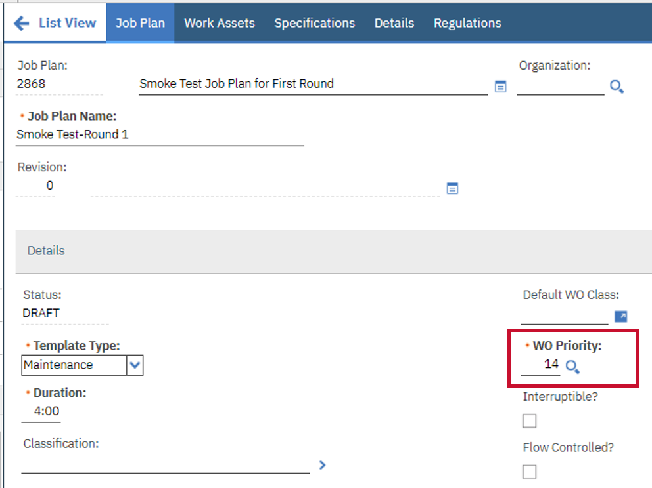
- Enter the priority of this Job Plan in the WO Priority field. In this example, 14 is entered.

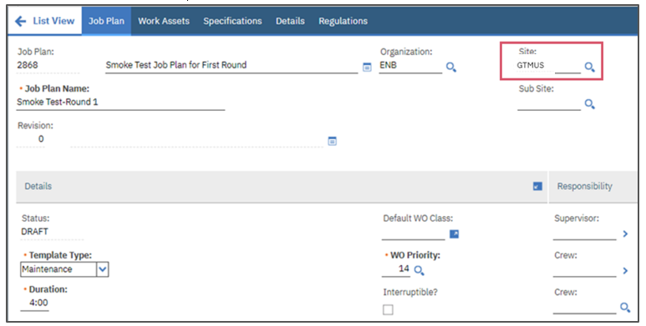
- Enter the required values in the Site field. In this example, GTMUS is selected as the Site for this Job Plan.

- Enter the required values in the Inspection Form field. In this example, 1113 is selected as the Inspection Form for this Job Plan.

Note: The Inspection Form chosen is copied over to a Work Order when a Job Plan is applied to a Work Order. This option is used when you need to associate an existing active Inspection Form to a Job Plan.
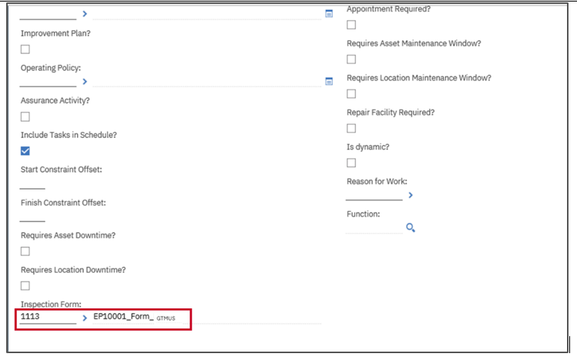

- Click the Save icon.
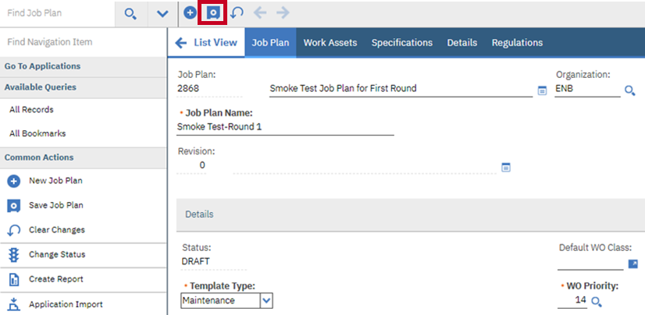
Note: The Change Status option is visible only to the MMS Team and not to the Planners. The Change Status option is a key functionality involved in activating a Job Plan. Once a job plan is approved, the MMS Team activates the Job Plan.

A notification confirming the Job Plan initiation is displayed on the screen.

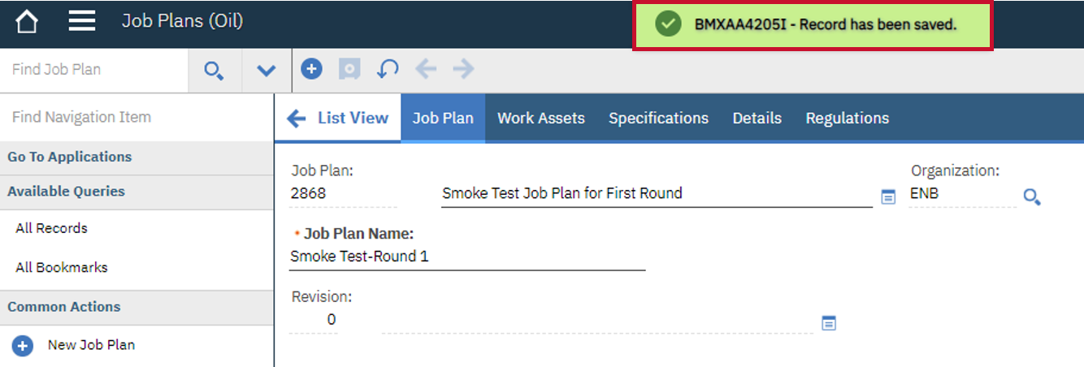

Add Tasks to a Job Plan
Tasks describe operational steps to complete a Work Order. A Job Plan requires a breakdown of all the tasks involved to complete the Work Order. When adding tasks to a Job Plan, ensure adding as much information, as possible. Below are the steps to add Tasks to a Job Plan in Maximo:

Steps
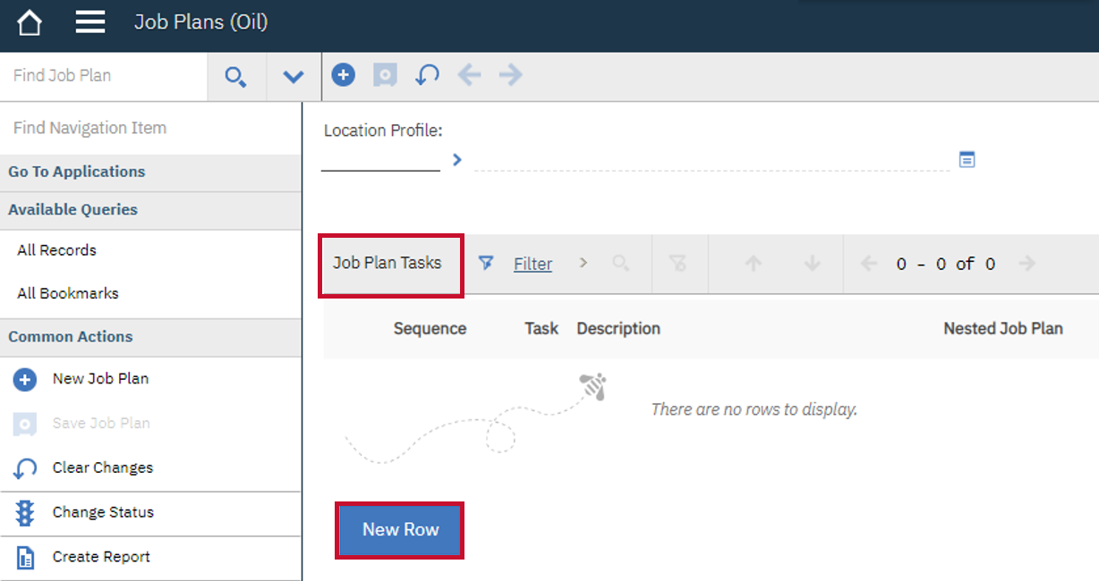
- Navigate to the Job Plan Tasks section in the Job Plan page and click the New Row button to create a new Task record.

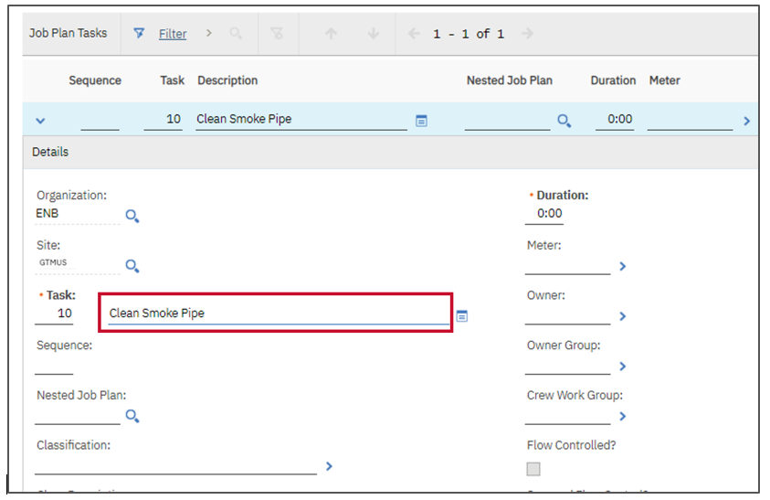
- Enter a brief description of the Task in the Description field.

- Enter an estimated time period (in hours) for completing this task in the Duration field.
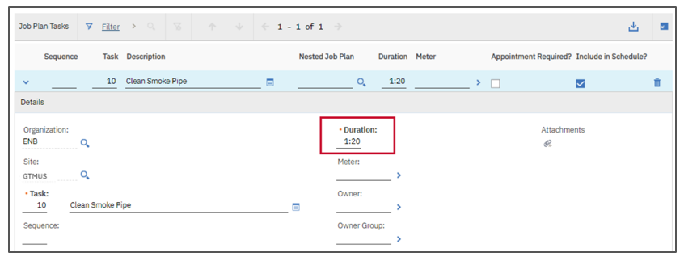
Note: The Duration field is automatically populated based on the assigned Task as the Task hours will flow to the Labor table, when selected. However, if the Labor record is not associated to a Task, the regular hours in the Duration field should be manually updated.

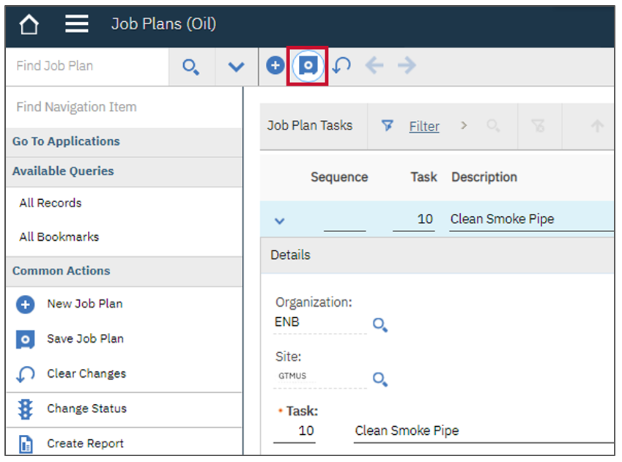
- Click the Save icon to save the newly added Task to the Job Plan.

Note: You can repeat the above steps until all associated Tasks have been entered into the Job Plan.

Add Planned Labor to a Job Plan
You add Labor or Craft either at the Job Plan level, or at various Task levels. Labor requirements for a Job Plan can be added and associated with the Tasks created previously. Below are the steps to add Labor to a Job Plan using the Labor sub tab in the Job Plan tab:

Steps
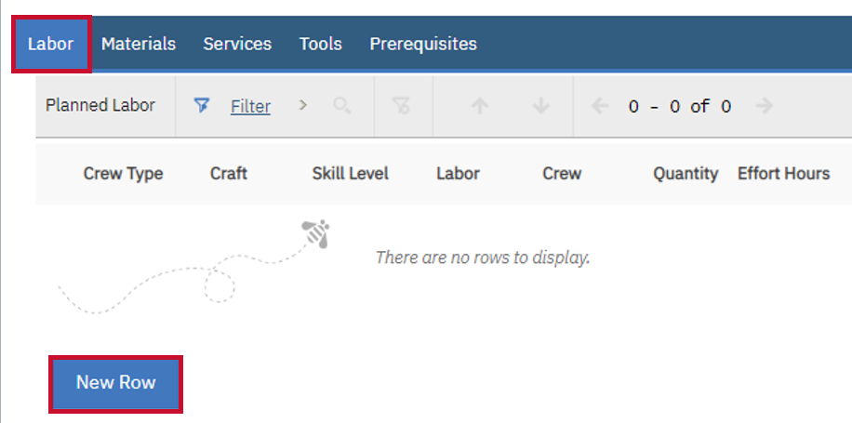
- After adding Tasks to the Job Plan, scroll down to navigate to the Labor tab and click the New Row button.

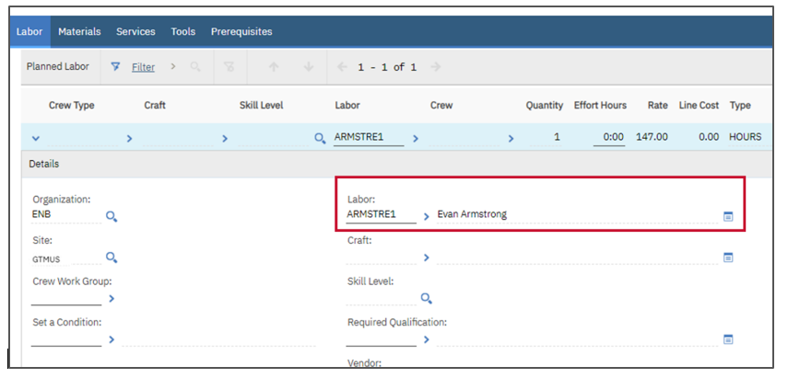
- Enter the required value in the Labor field. In this example, ARMSTRE1 is entered.

- Scroll right and enter the time required for this Planned Labor in the Effort Hours field.
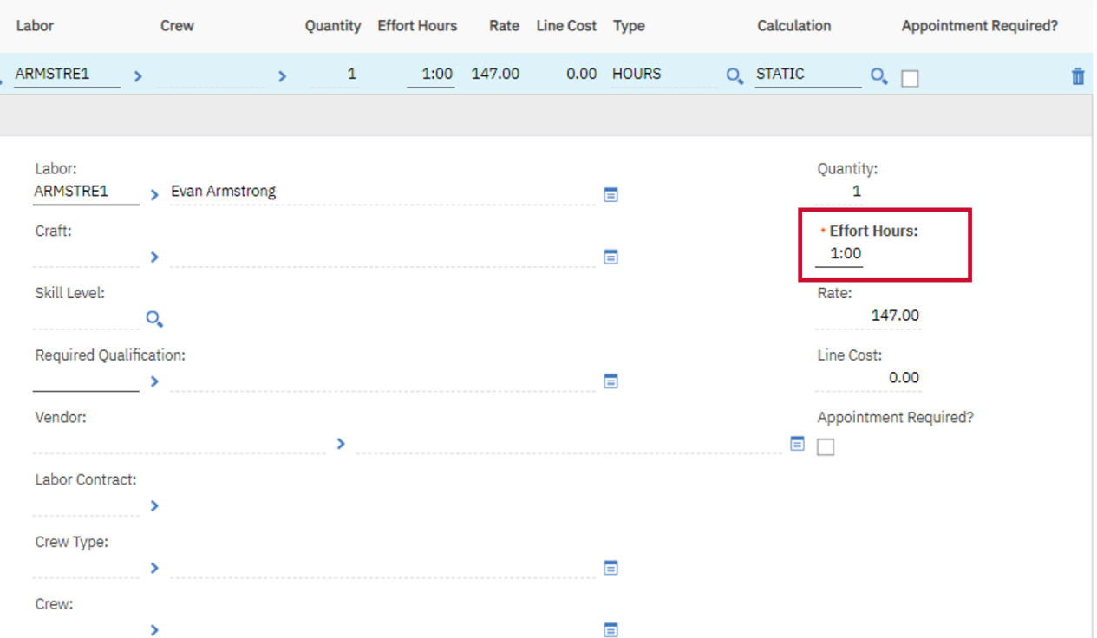

- Update the Quantity field to adjust the quantity required for the Labor. By default, the value is 1.
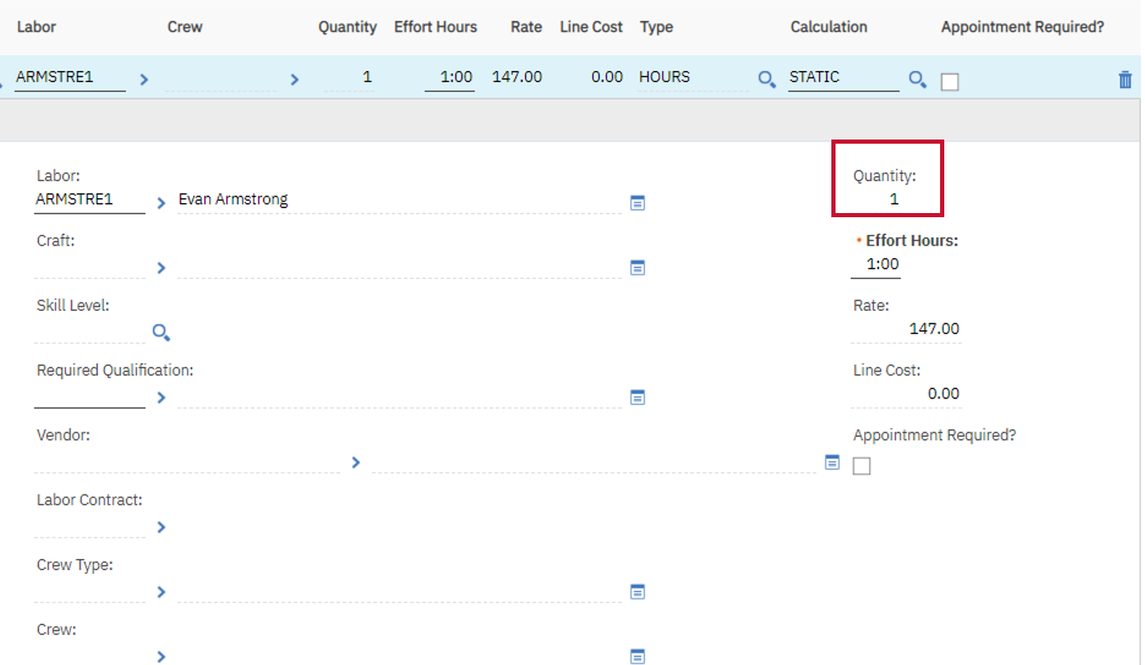
Note: Save the changes and repeat the above steps until all the Labor required for the Job Plan have been added.

Add Materials to a Job Plan
Materials required for the job can be added to the Job Plan in two different ways. They can be added by:
- Using the Asset Spare Parts list
- Using the Inventory list
Below are the steps to add Materials to a Job Plan by using the Asset Spare Parts list in Maximo:

Steps
- Navigate to the Materials tab and click the Select Spare Parts button to view a list of asset spare parts.
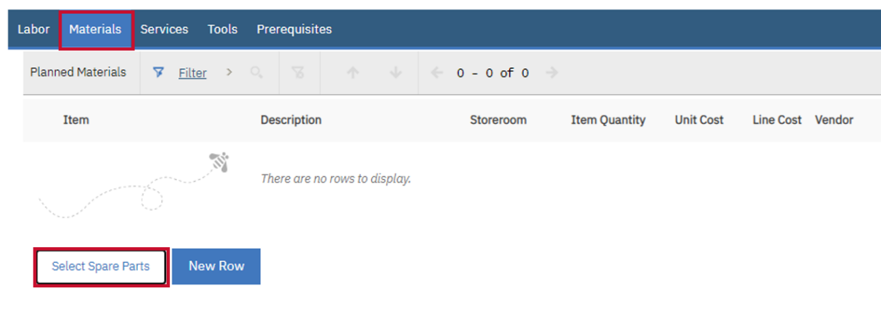

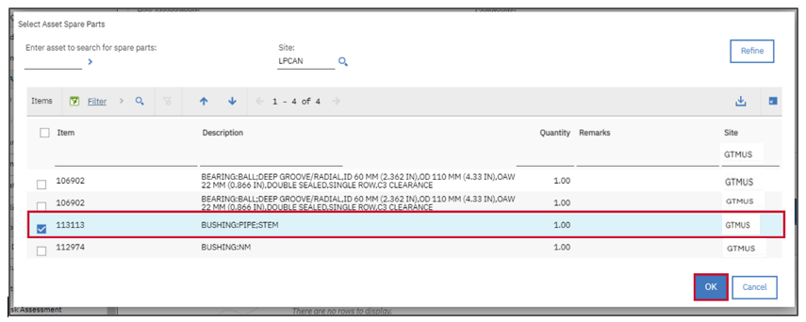
- In the Select Asset Spare Parts pop-up window, select the required Item checkboxes from the list and click OK. In this example, 113113 is selected.

Note: Depending upon the requirement, you can update the values in the Storeroom and Item Quantity fields, if required. The default value available in the Item Quantity field is 1
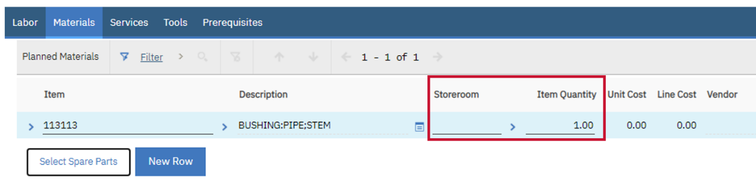
Note: Save the changes and repeat the above steps until all Materials required for the Job Plan have been added.

Note: Save the changes and repeat the above steps until all the Labor required for the Job Plan have been added.

Add Materials to a Job Plan Using Inventory List
Below are the steps to add Materials to a Job Plan by using the Inventory list in Maximo:

Steps
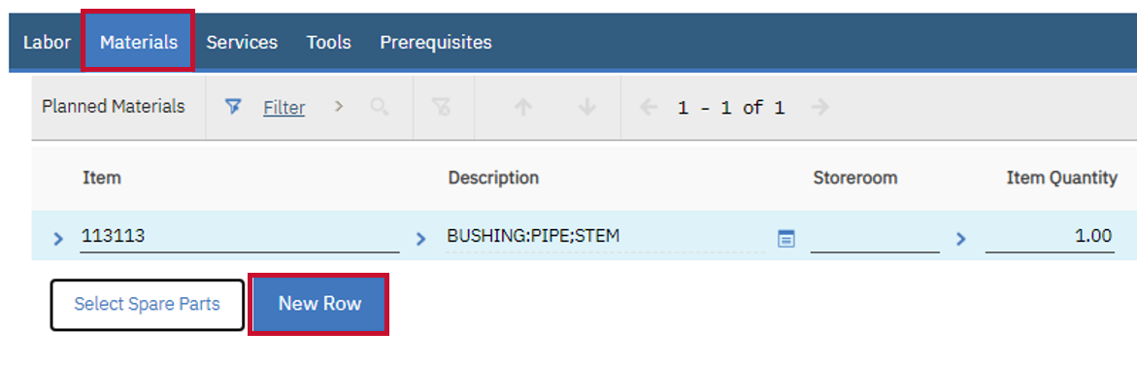
- Navigate to the Materials tab and click the New Row button to create a blank Material record.

- Enter the Item number in the Item field.

Note: If the Item number is not known, click the Detail Menu icon to search or filter for the required Item.
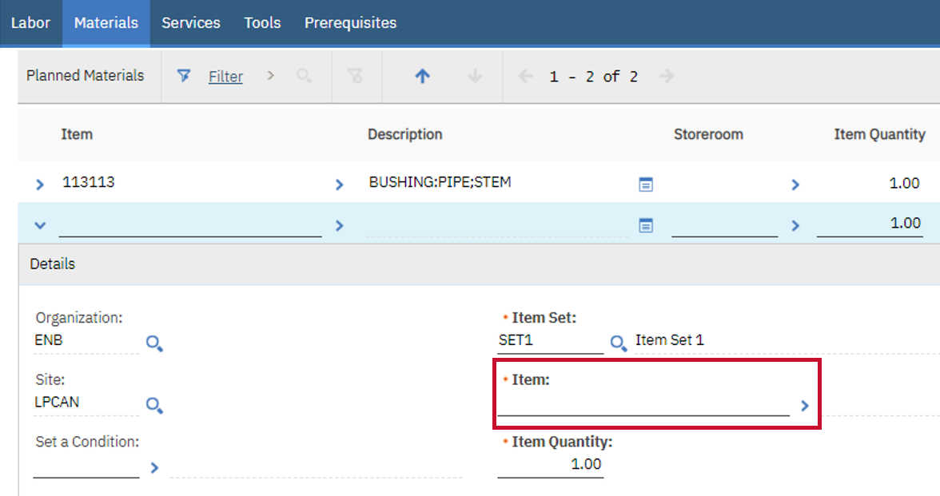

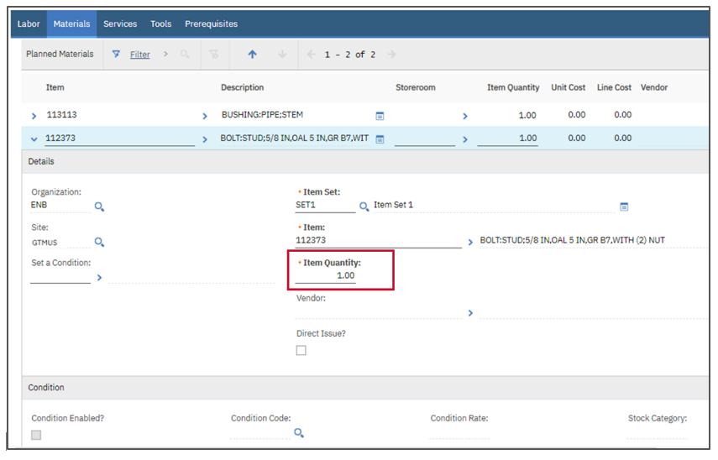
- Update the Material Quantity field, if required. The default value available in this field is 1. Depending upon the requirement, you can update this value as required.

Note: Save the changes and repeat the above steps until all Materials required for the Job Plan have been added.

Add Services to a Job Plan
Below are the steps to add Services to a Job Plan in Maximo:

Steps
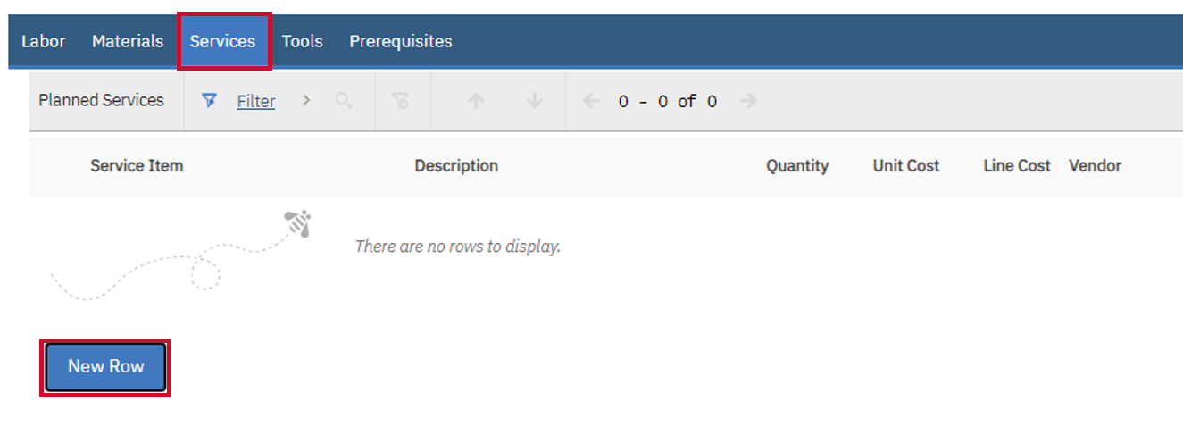
- Navigate to the Services tab and click the New Row button to create a Service record for this Job Plan.

- Enter the Service Item number in the Service Item field.

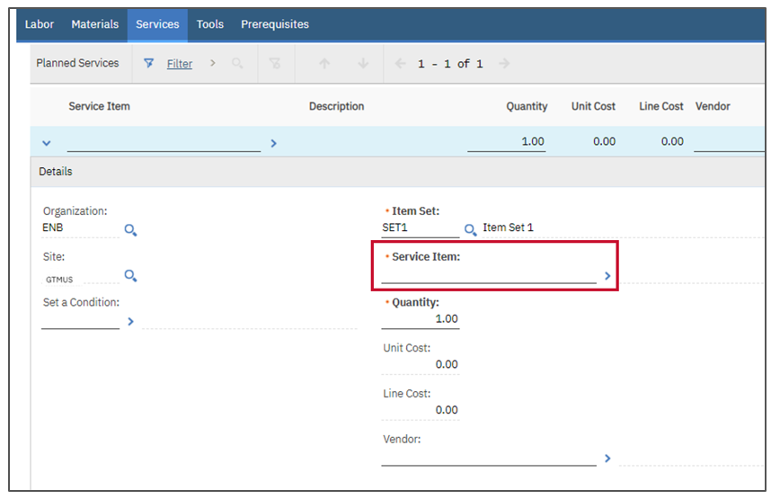
Note: If the Service Item number is not known, click the Detail Menu icon to locate and select the required Service Item.

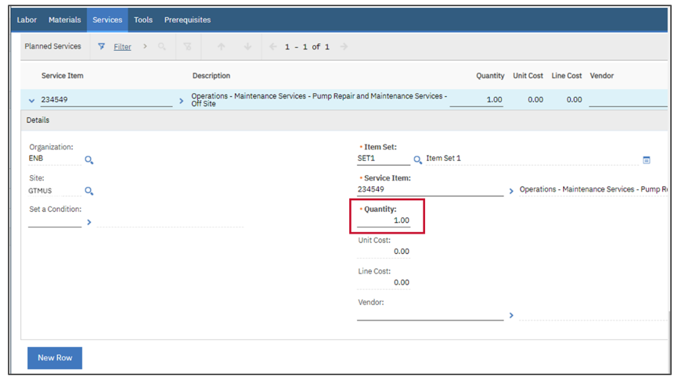
- Update the Quantity field, if required. The default value available in this field is 1. Depending upon the requirement, you can update this value as required.

Note: Save the changes and repeat the above steps until all Services required for the Job Plan have been added.

Duplicate a Job Plan
Below are the steps to duplicate a Job Plan in Maximo:

Steps
- After logging into Maximo, select the Go To icon, select the Planning option, then select the Job Plans (Oil) application.

- Open the Job Plan that you want to duplicate. Navigate to the More Actions menu and select the Duplicate Job Plan option.
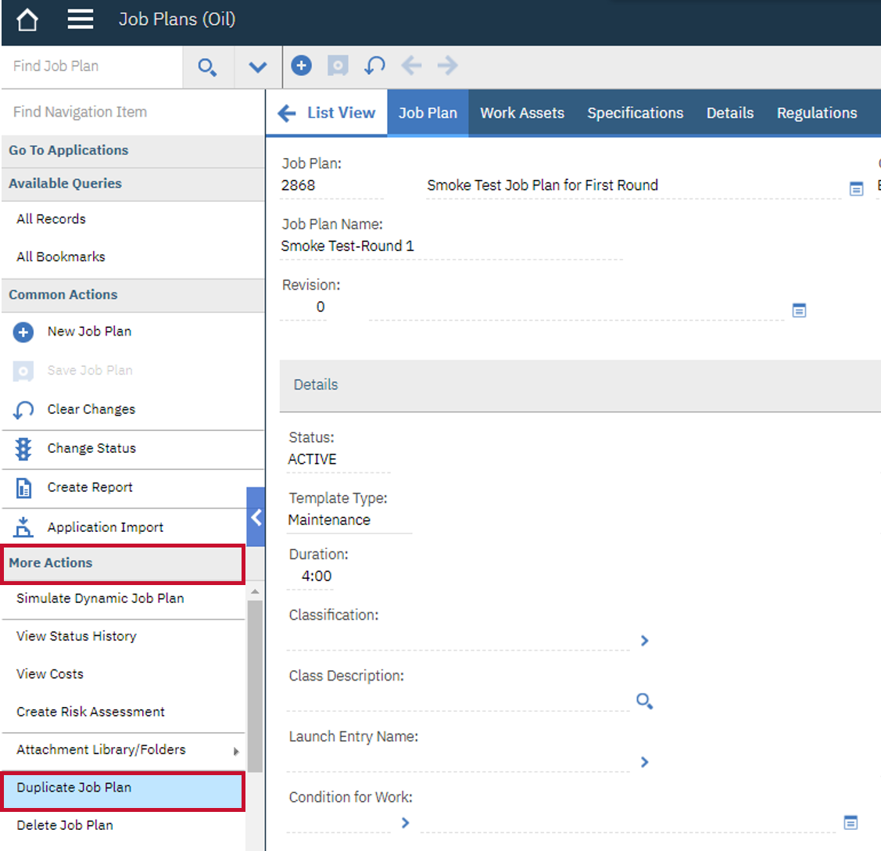

Note: A new Job Plan displays in DRAFT status along with the duplicated fields. Update the Job Plan details as required.
